1. What physical quantity are we measuring in our experiments? How many sensors (e.g., electrodes) are required?

**A:** We are measuring the amplitude and frequency of spikes, using two electrodes; the reference and recording electrode.

1. What would happen if you reversed the ‘ground’ and ‘recording’ electrodes? (1 sentence)

**A:** The signal would be inverted, as the resulting signals is the difference of the recording and ground electrodes.

1. When one electrode is in the femur and one in the tibia, there is a lot of “background activity”. The amount of background activity (increases, decreases) when the electrodes are close together (both in the tibia). Explain briefly (1-2 sentences) why.

**A:** When the electrodes are separately placed in the femur and tibia, the signals from the recording electrode are being referenced (subtracted) by the reference electrode of a different set of neurons, not the same set of neurons as the recording electrode. When both are closer together in the tibia, the signal decreases close to or becomes zero, as both are recording and referencing from the same set of neurons, resulting in a net ~0.

1. In experiment 2, we found that the properties of recorded signals changed significantly with the properties of the electrodes. Summarize how the amplitude and signal-to-noise ratio (SNR) is impacted by electrode properties (bulleted list of findings). Are these findings consistent with the proposed hypothesis of the experiment?

**A:** The size of an electrode is inversely proportional to the impedance and resistance, as it controls the flow of current through the electrodes. Moreover, impedance influences the occurrence of shunting and thermal noise, which in turn influences signal loss and SNR. Additionally, the electrode size will influence how many neurons are sensed within its vicinity, with farther ones not picked up due to the electric field generated by the neuron falling off quadratically, thus influencing the amplitude. Also, the neurons sensed by the reference may overlap with those of the recording if large and/or close enough and can result in a net zero amplitude signal. The findings were mostly consistent with the hypothesis, except for a few outliers, which may be a result of error.

1. Looking at the waveforms and distributions of peak-to-peak amplitude for your various recordings, we see that sometimes we see multiple categories of waveform (distinct peaks, different waveforms). What does this reflect? Is there a trend in what types of recordings produce these distinct peaks?

**A:** This is a result of the different placements of the electrodes which detect different groups of neurons, as well as the electrode size which detects either a portion of the neuron group or detects additional neurons.

1. What is the largest source of error in your results? How might you change your experimental design to improve your results?

**A:** A possible source is improper placement of the electrodes, resulting in too many repeated punctures, death of neurons in the leg, and possible inaccurate results as well as too much noise. A change I might make is to prepare three separate legs for each electrode size, to reduce repeated punctures for the electrode location variable together with the electrode size variable.

1. Based on what you learned about the impacts of electrode placement and size in lecture, describe the best measurement set-up to record highly localized neural signals (electrode placement, electrode properties). Does this agree or disagree with what you observed in your experiments?

**A:** The best measurement set-up would be to use medium (00) electrodes placed close (but not too close) together in one area. This is confirmed in our experiments as using a large (0) or small (000) electrode did not result in large enough and/or consistent spikes (if any signal), in spite of better SNR with the large electrode. Also, with the same electrode size, too far of a distance resulted in either nonsense or very faint spikes, whilst general vicinity (but not close) also resulted in faint spikes.

1. Append all figures generated by running the data analysis scripts (underlined in the experiment description) to your comprehension questions.

**A:**

**Experiment 1**

**Figure 1**

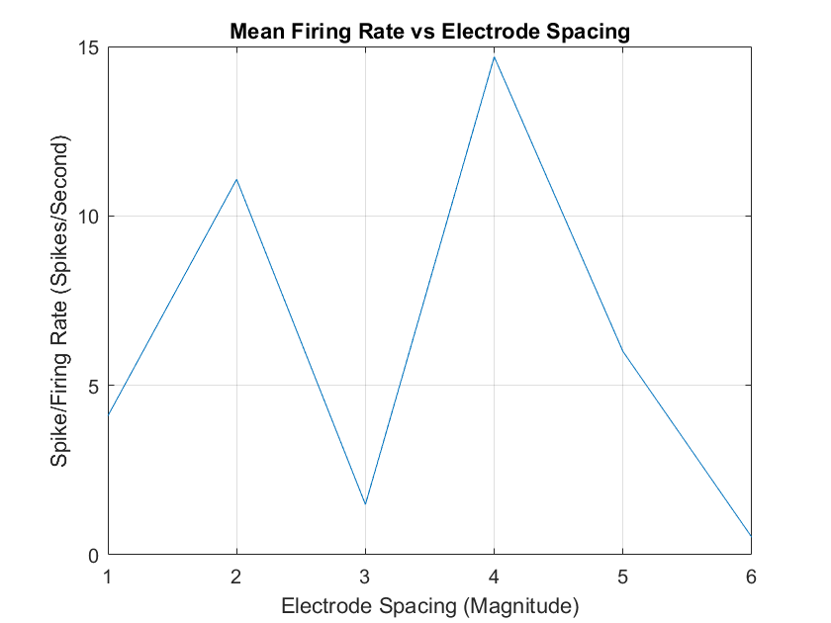

**Figure 2**

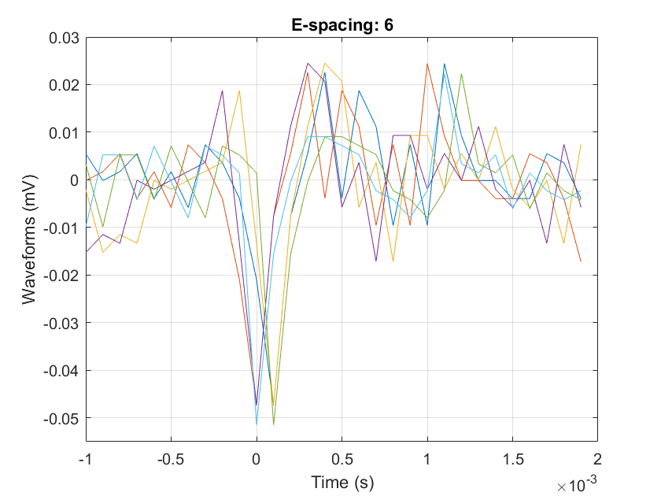

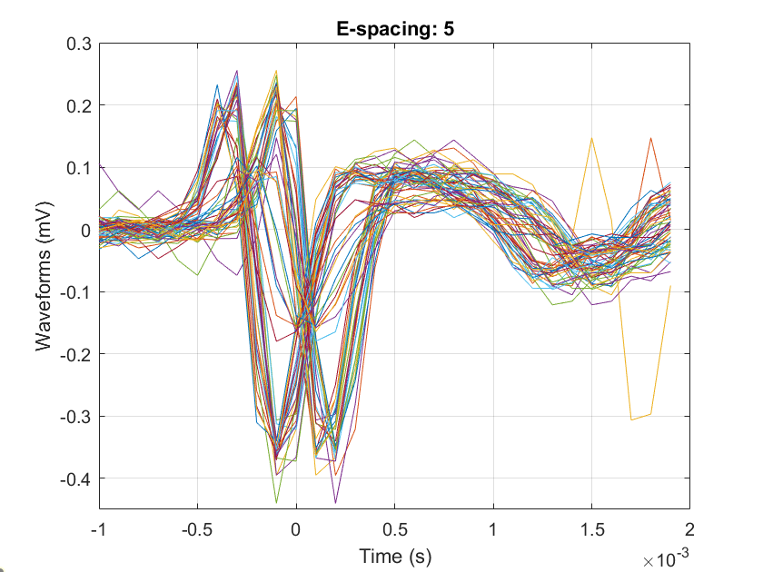

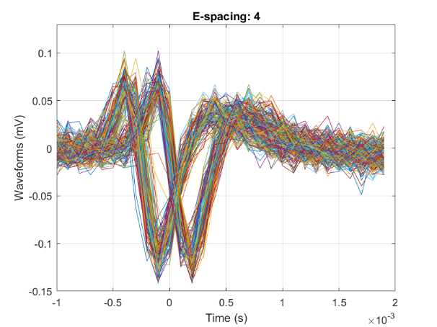

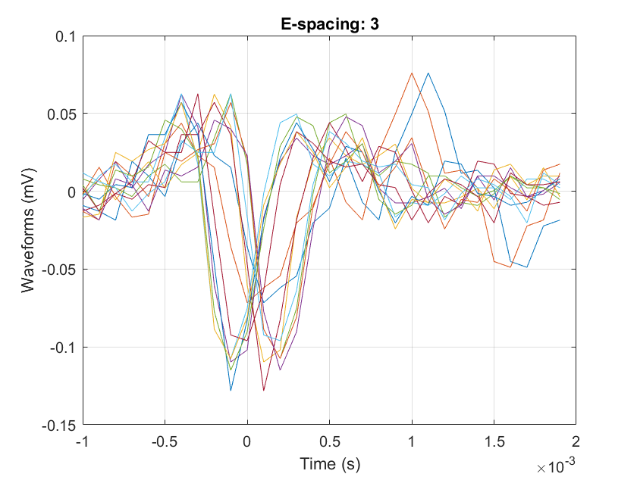

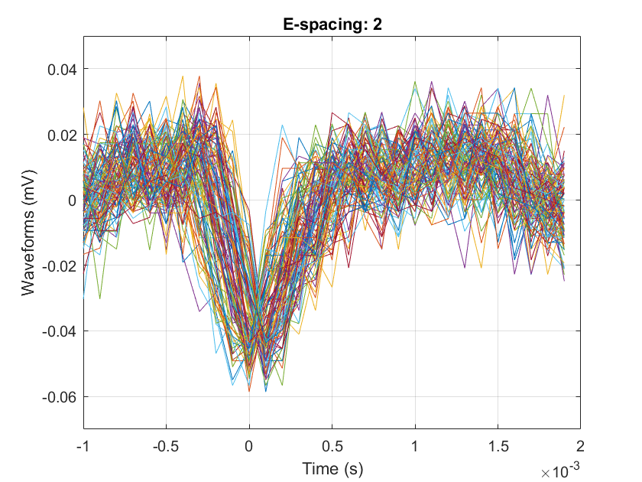

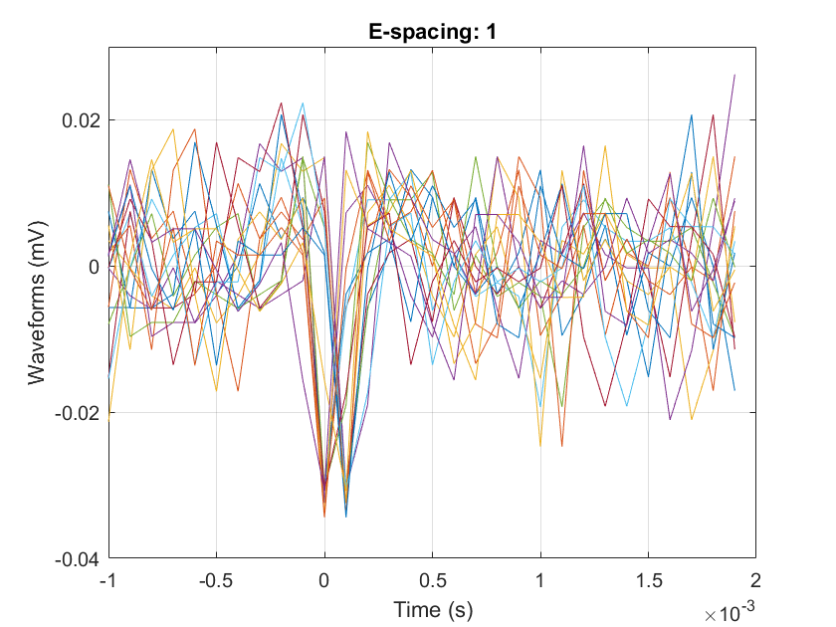

**Figure 3**

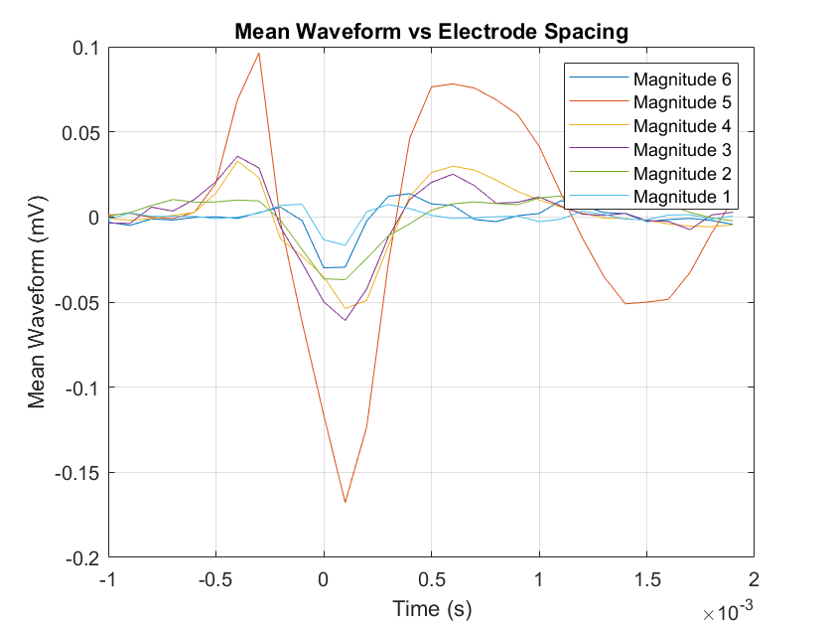

**Figure 4**

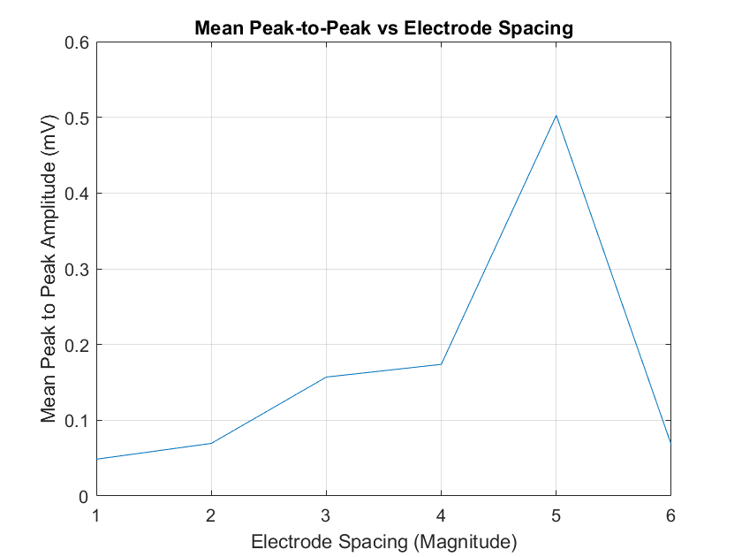

**Figure 5**

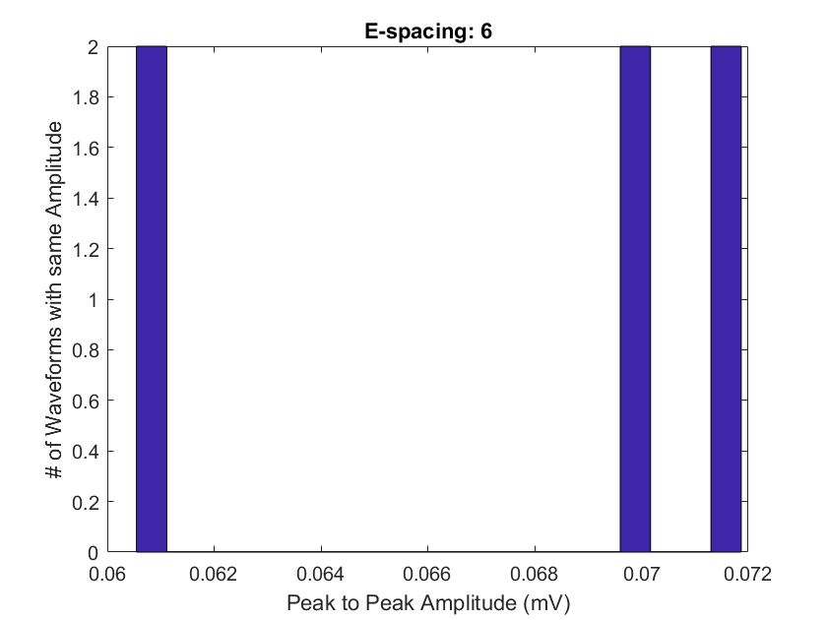

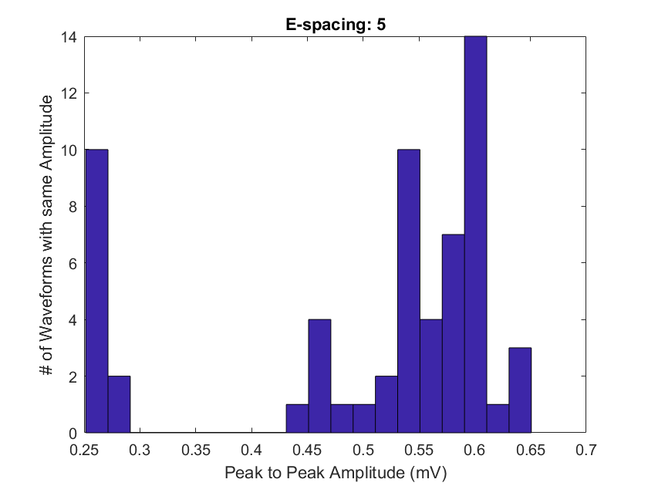

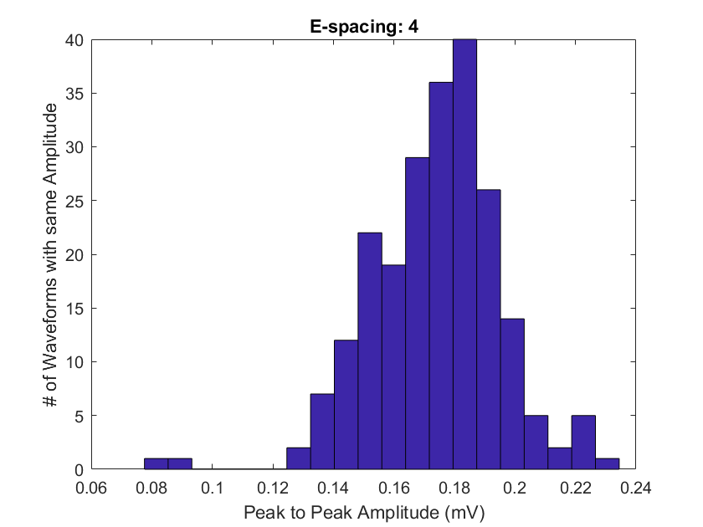

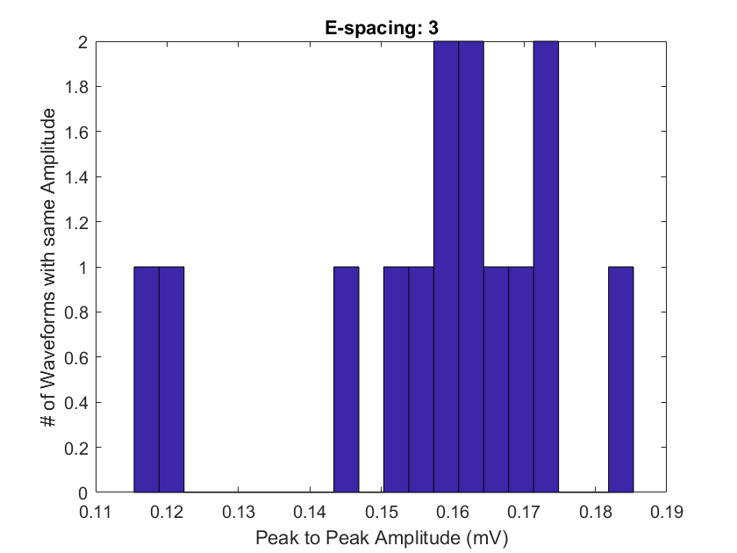

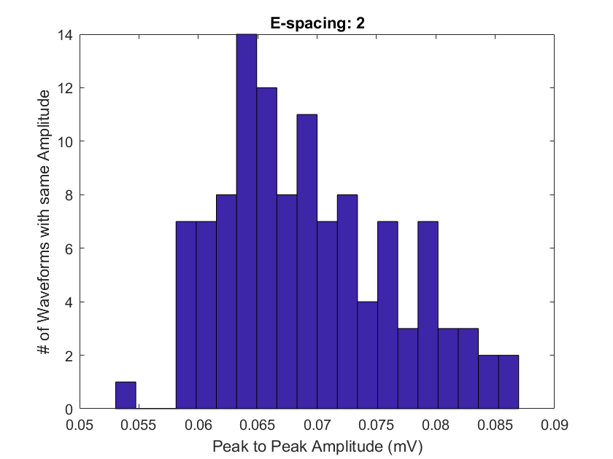

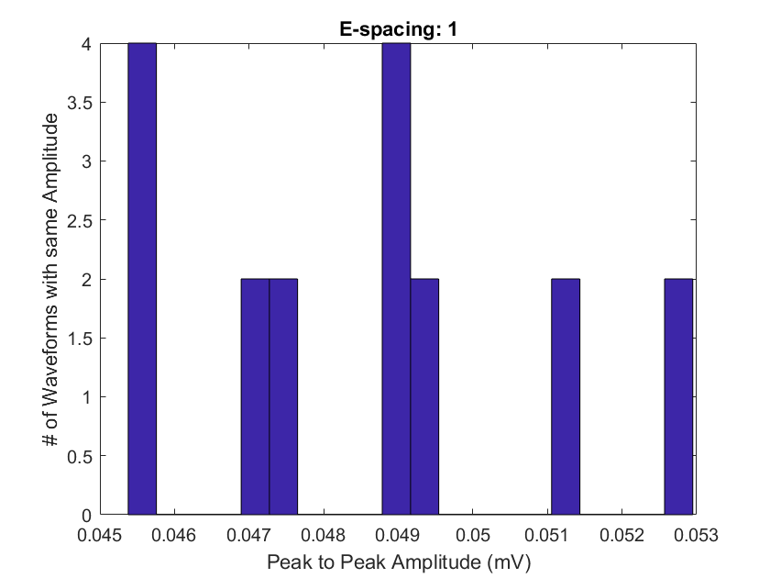

**Experiment 2**

**Figure 1**

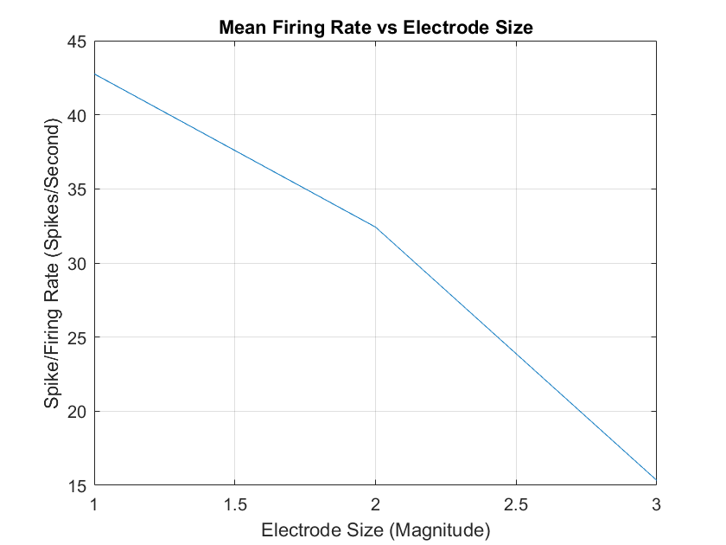

**Figure 2**

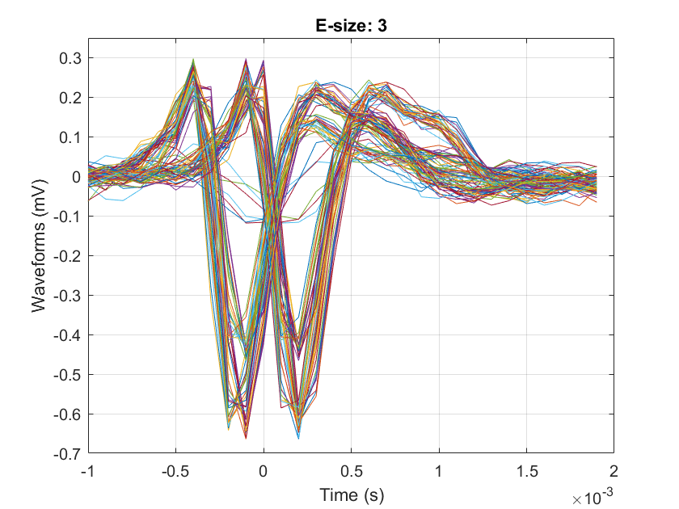

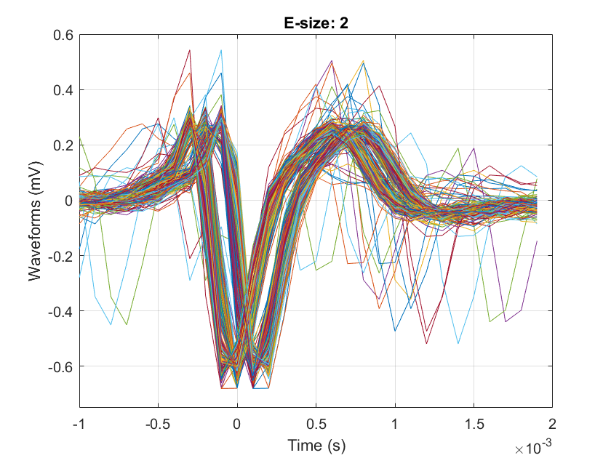

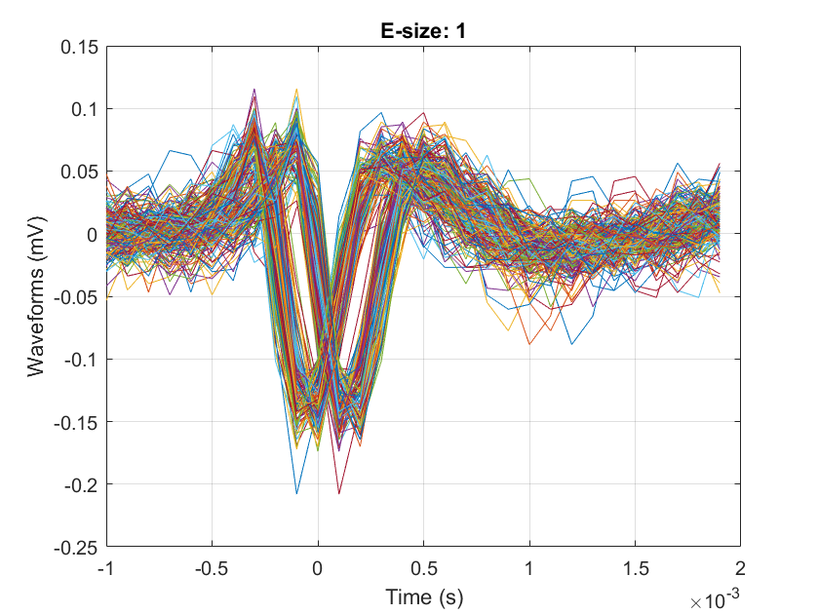

**Figure 3**

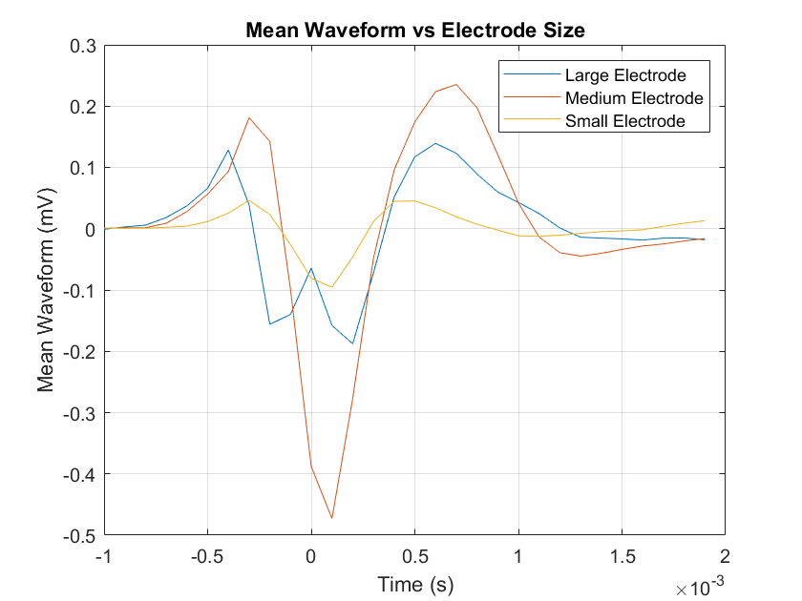

**Figure 4**

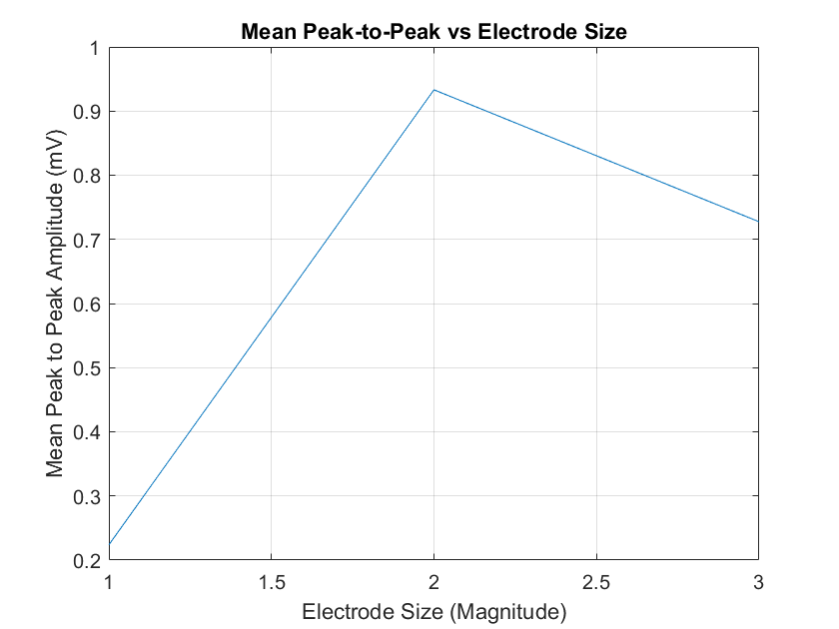

**Figure 5**

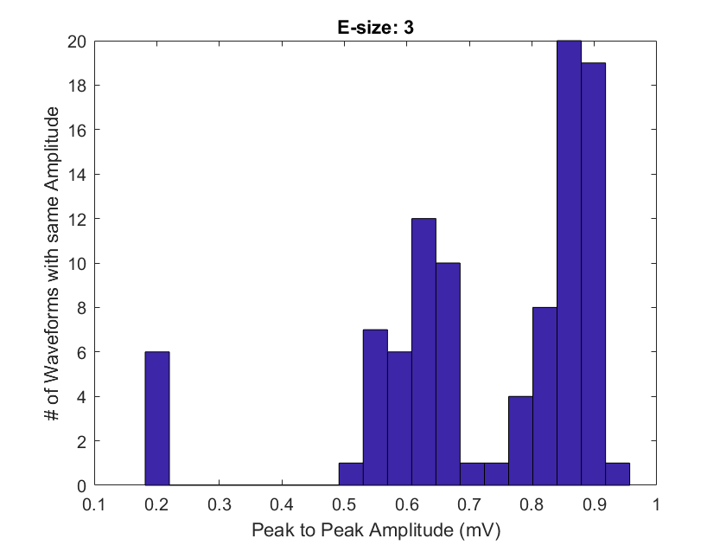

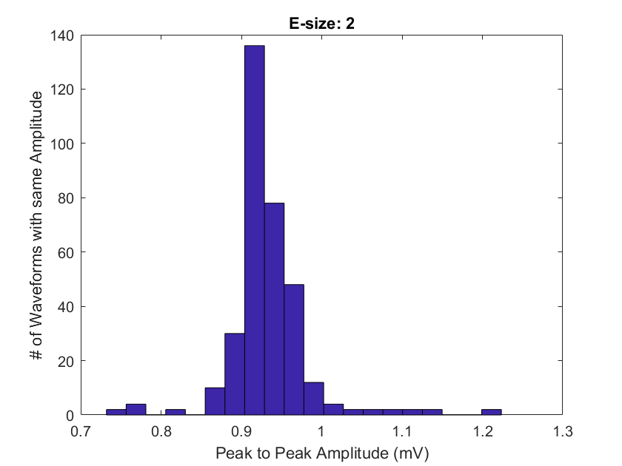

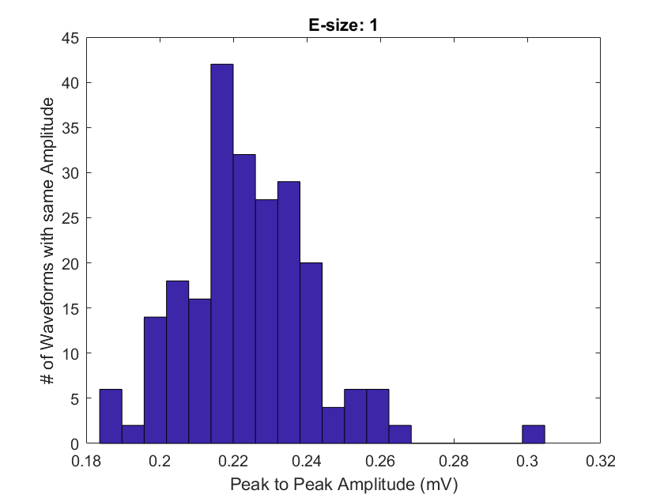

**Figure 6**

